- Prepare build environment
On the following environment, we recommend to use Ubuntu14.04
- Get LLVM: please contact Qualcomm to get the Compiler
https://developer.qualcomm.com/software/snapdragon-llvm-compiler-android
Install the compiler to /pkg/qct/software/llvm/release/arm/
- Get Hexagon SDK: please contack Qualcomm to get the DSP SDK
https://developer.qualcomm.com/software/hexagon-dsp-sdk/tools
Install the SDK to /opt/Qualcomm/HEXAGON_Tools
- Get license DS-5
https://developer.arm.com/tools-and-software/embedded/legacy-tools/ds-5-development-studio
Indtsll to /opt/DS-5
- Get Metal
https://www.linaro.org/downloads/
Install to /pkg/qct/software/arm/linaro-toolchain/
- Change python link
$ sudo mkdir -p /pkg/qct/software/python/2.7/bin
$ sudo cd /pkg/qct/software/python/2.7/bin
$ sudo ln -s /usr/bin/python2.7 python
- Prepare android environment
# Android_env.sh
mkdir -p ~/bin
wget 'https://storage.googleapis.com/git-repo-downloads/repo' -P ~/bin
chmod +x ~/bin/repo
sudo apt-get install -y openjdk-8-jdk
sudo apt-get install -y android-tools-adb
sudo apt-get install -y bc
sudo apt-get install -y bison
sudo apt-get install -y build-essential
sudo apt-get install -y curl
sudo apt-get install -y flex
sudo apt-get install -y g++-multilib
sudo apt-get install -y gcc-multilib
sudo apt-get install -y gnupg
sudo apt-get install -y gperf
sudo apt-get install -y imagemagick
sudo apt-get install -y lib32ncurses5-dev
sudo apt-get install -y lib32readline-dev
sudo apt-get install -y lib32z1-dev
sudo apt-get install -y libesd0-dev
sudo apt-get install -y liblz4-tool
sudo apt-get install -y libncurses5-dev
sudo apt-get install -y libsdl1.2-dev
sudo apt-get install -y libssl-dev
sudo apt-get install -y libwxgtk3.0-dev
sudo apt-get install -y libxml2
sudo apt-get install -y libxml2-utils
sudo apt-get install -y lzop
sudo apt-get install -y pngcrush
sudo apt-get install -y rsync
sudo apt-get install -y schedtool
sudo apt-get install -y squashfs-tools
sudo apt-get install -y xsltproc
sudo apt-get install -y yasm
sudo apt-get install -y zip
sudo apt-get install -y zlib1g-dev

- Download SDX55 source code from codeaurora
https://wiki.codeaurora.org/xwiki/bin/QLBEP/release
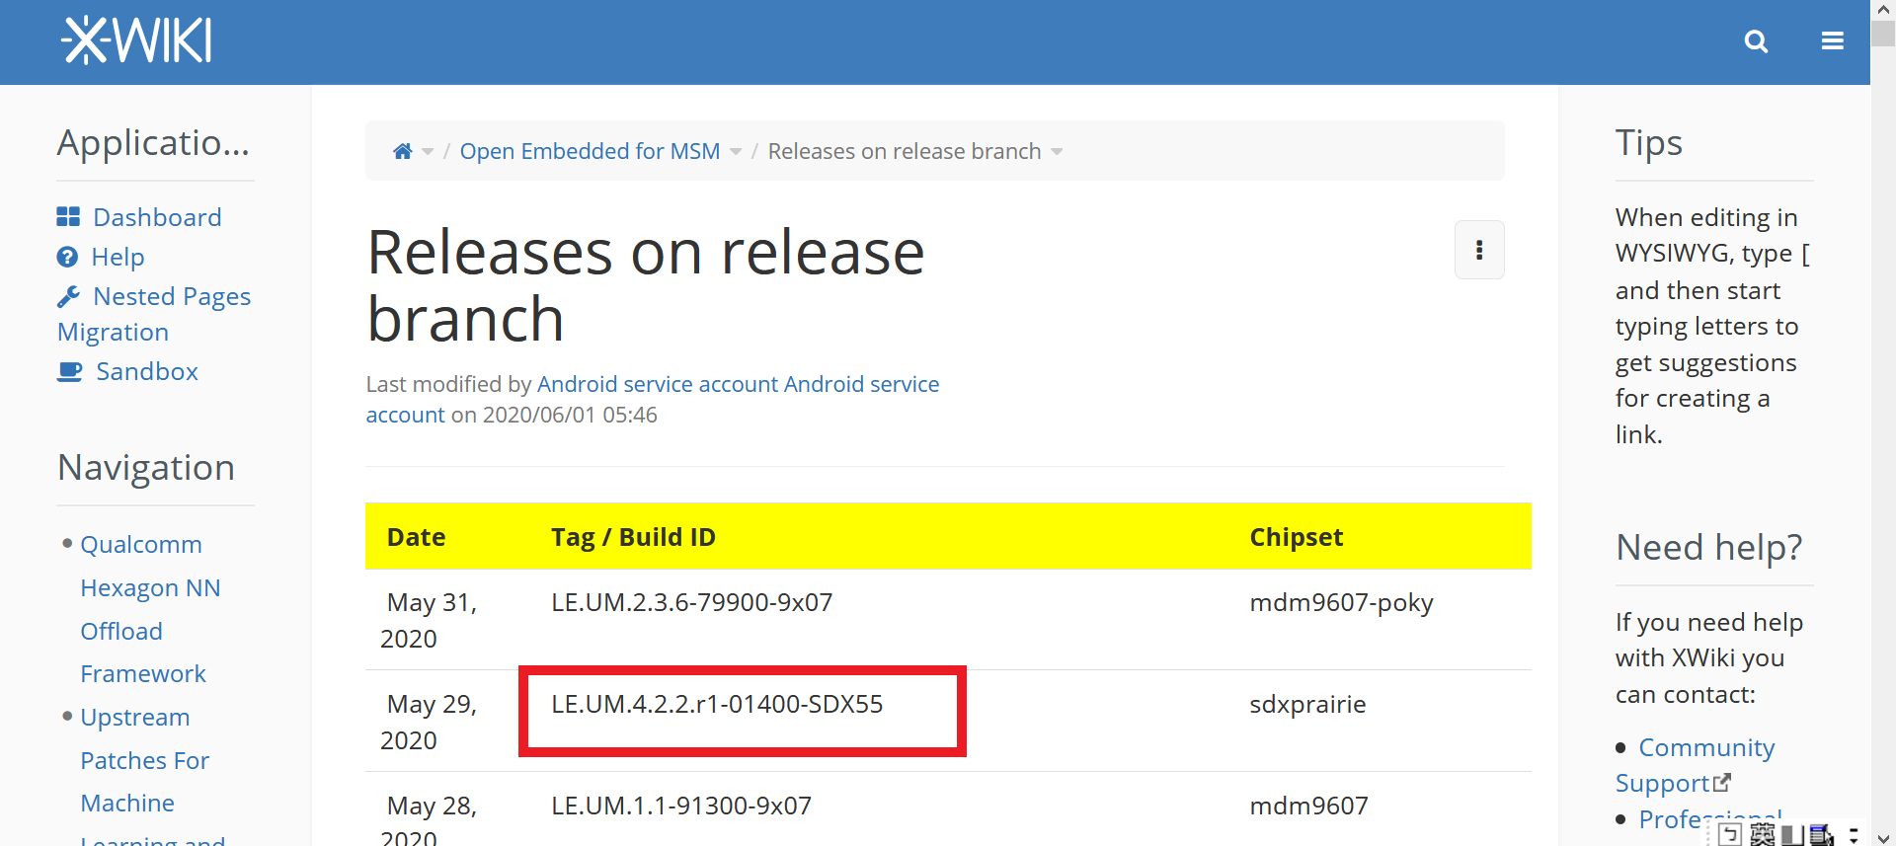
Ex: caf_msm-4.14-LE.UM.4.2.2.r1-01400-SDX55.tar.gz
- Build the system.
Please reference the webpage.
https://source.android.com/setup/build/building-kernels


